Equity in Action Project
Equity Action Plan Overview
School District #91
2018/2019

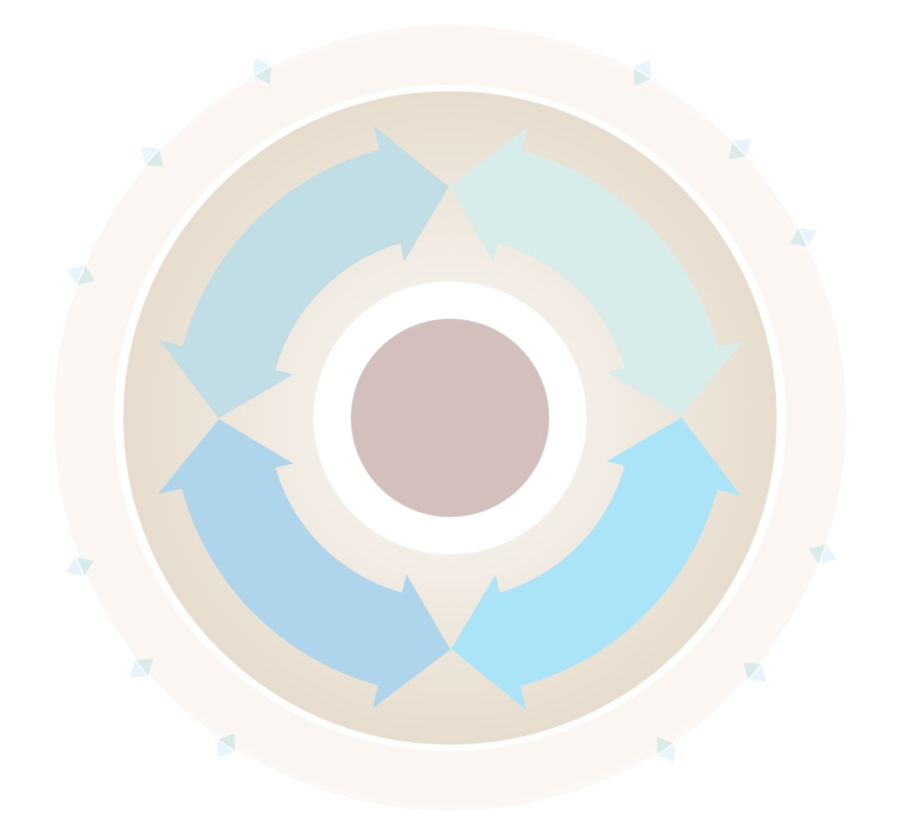

Project Overview: Describe your approach to Equity in Action this year. How did you engage the process and how was the experience received in your district?

Our approach to Equity in Action was based in the idea of this being an opportunity to shed some light on the truths in public education and being courageous in finding out what they are. We ensured that from the start to where we ended the process this year that we engaged both our knowledge holders and our rights holders. Our process was also dictated by the size of our district and was guided by the input of the 14 First Nations, whose land we both live and work on. Our district is 70,000km² and has 6 main town sites. In order to facilitate meaningful engagement we used a family of schools model and hosted 4 separate meetings which were hosted by our 4 bricks and mortar high schools. We ensured that at each of these meetings there was representation from our student body, First Nations leadership, Teachers, support staff, administrators and parents. Upon the conclusion of our initial scanning tool meetings it was apparent that the voice that was resonated the most and the one that we needed to engage with the most was the voice of our students. A critical piece of our Equity Scan has been the student voice research that we are currently completing. By the end of this year we have concluded our scan, developed our theory of change and action plan, and are wrapping up our student research. During the summer, we will be sitting down and reviewing the learning tool and student data to inform our next steps and to engage our rights holder partners. We have committed in all four family of schools teams to continue to meet bi-annually to review our progress in the creation of a system is equitable for all students and to adjust our action plans to continuously meet the changing needs of our communities.
Building an Equity Scanning Team: How did you engage rightsholders (First Nations), key stakeholders, and other partner groups in your district’s Equity Scanning Team? How did you communicate and bring people to the table? What key strategies did you employ in developing your equity scanning team and what were the results? How did you determine whether anyone was missing and what voices needed to be included?

In School District #91 we have great relationships with our rightsholder partners. The 14 First Nations make up most of the First Nations Education Council, the advisory body in Aboriginal Education. There are several key things that have reinforced our relationships with rightsholders:
- Transparency
- Not meeting with predetermined outcomes
- Meeting them within their communities
- Constant communication and involvement
- Listening to and reflecting on feedback
This is also true of the stakeholders groups within our district. We have open and constant collaboration with our union groups and our administrative team. It was our high school based administrators that were the driving force behind helping facilitate the meetings that occurred during the year. Our late Superintendent, Eugene Marks, often said, “When people stop asking questions we will know we are in trouble.” It is this sentiment that is reflected in the current way that we engage with all of our partners. It was determined early on that the only voice that needed to be engaged was the voice of our Elders. We also agreed that it would be best that they be on the district level equity scan committee. We wanted to be mindful of their time and respectful of the many obligations our Elders currently have.
Conduct the Equity Scan: How did you approach the Equity Scanning Processes? Describe your approach to engaging the 32 guiding questions of the Equity Scan Workbook? Who did you engage in your scanning and what strategies did you use? Did you add, edit, reduce or cohort the guiding questions provided for your district scanning process? What artifacts and structures were created through Equity in Action? (If you created unique questions, presentations, surveys, and other approaches, please consider sharing as an appendix).

We held 4 meetings with each family of schools equity scanning teams. We started this meeting by giving an overview of Equity in Action and went over the guiding questions. We separated the large group into several table groups. The size of the groups varied from community to community, but we consistently ensures that there was equal representation of both rightsholders and stakeholders at each of the tables. We asked the groups to choose a recorder and to read the questions to the entire group. We made sure that there was clear understanding of the questions by all the participants and had to paraphrase and explain some of the questions. During the scanning process we made ourselves available and moved around the room to support the process. It helped for us to set some time limits around each section in order to complete the entire questionnaire. We gave a total of 45 minutes for each section to be completed by the group. This was done on purpose in order to give a sense of urgency and for the groups to focus on the questions. When all of the data from each meeting was collated the data was sent back to the groups to read over. We then sent a follow-up survey that asked them on their thoughts on the data, the rubric and the scoring done by the group (Appendix 1). Both the initial scanning raw data and then survey data were used as the basis for developing the Theory of Change and Action Plan.

Develop a District Equity Profile: What are the greatest areas of focus from your findings? What parity and equity gaps exist for Indigenous learners? Describe some of the key findings specific to each of the Equity Scan Framework quadrants: Policy and Governance, Learning Environment, Pedagogical Core and Learning Profile? What are your insights into how to maintain momentum and ensure that the Equity remains a key focus? How do we collectively bring equity practices to life each and every day?

Overall, our findings in each of the family of schools groups found consistently that there was a strong foundation to build on, but identified several key challenges that we face as a district in order to improve outcomes for Indigenous learners.
Policy and Governance: There is a lack of knowledge and awareness of policies that guide Indigenous education within our School District. It has also been identified that there needs to be an alignment of policy and it was suggested that any policies that are developed should be actionable. In the next year, we will be exploring Aboriginal or Indigenous education policies in the province and will revamp our existing policy to reflect the changes in our system.
Learning Environment: There are great efforts being made to ensure that the learning environment reflects the diversity of our student body and that there are supports in place that ensure equity. The overall feedback suggested that there needs to be more communication between the schools, community and the home. There is a need for relationships to be either developed or continued to be nurtured. It was clear that increased awareness of programming is needed. It was identified that increased culture and language programming needs to be a priority for our district.

Pedagogical Core: It was expressed that there needs to be increased opportunities for professional development for all staff. It was felt that there needs to be more professional development day offerings throughout the year to support teachers in their learning. There are many examples throughout the district how this work is being done in the classroom that incorporates Aboriginal Worldviews and Perspectives and there will be an effort to share best practice in an effort to increase this in the coming years. In response to the BCTEA, we are hosting a conference and professional development opportunities throughout the year as a starting point.
Learning Profile: The learning profile data confirmed what we already knew about Indigenous learners within our district. We know that if we are able to help students transition to Grade 12 that the grad rate for Indigenous students is as high as or higher than their non-Indigenous counterparts. It also showed that there is a consistent effort amongst staff to ensure that graduation requirements are being met. There is room for improvement and we will continue to monitor student data and share this data, with permissions, with our 14 First Nations communities. The Learning Profile tool will continue to be another tool that we use in order to create an equitable system.

Theory of Change and Equity Action Plan: Describe your district’s Theory of Change. What findings and learning have emerged through this process that will contribute to growth and progress for your organization? What intentional strategies, actions and goals have you identified for action to address inequities and systemic barriers that may exist?

Throughout the scanning process there were 3 key areas that were identified as areas of growth and change that would impact student achievement. They were improving communication, nurturing relationships and supporting professional development.
Improving Communication
The most feedback that we received in the scanning process is around communication. There are many things happening in Aboriginal education, but little awareness of it amongst stakeholder and rightsholder partners. We have developed a communication strategy that will ensure that there is a consistent effort to share out information to all groups in our communities. We will be launching our district Aboriginal education website in the fall. This is where most of the information will be housed and information will be disseminated from. We will have a quarterly newsletter and report that goes out as well as short videos that share our successes and showcase student voice. We will also be utilizing our social media platforms to ensure that we are having the biggest reach possible. We will also be hosting community meetings in the fall to bring awareness of the changes happening in Aboriginal education within School District 91. The last activity for this school year was a district strategic planning session. The four pillars of Equity Scan and the areas we had come up with in our Theory of Change were incorporated into the planning to ensure alignment of practice and policy.
Nurturing Relationships
We have taken feedback from each of our 4 family of schools Equity Scan meetings and have recorded best practice from each of the communities. Some of the recommendation and areas that we will be concentrating on is increased parent-teacher interaction at the community level. We have noted that the schools that have the strongest relationships to community are those that go to the First Nations communities to connect. An example of this is holding parent-teacher interviews in the hall of the local First Nation to improve parental engagement. We will increase knowledge holder interaction within schools. Schools that bring community in and have them as a regular part of the school day have strong relationships to community. A recommendation to schools is to create a network with community groups and First Nations in order to build capacity for students.
Supporting Professional Development
An area that was expressed by stakeholders within the system, teachers, support staff and administrators, that we are responding to is the need for increased professional development in order to impact the learning environment. A barrier that exists to this is consistent programming throughout the year. We are examining how this can be done in consultation with our teacher and CUPE groups in order to maximize learning opportunities for staff. At the administrative level, a three-year plan is being developed in order to ensure that school leaders have increased capacity in order to help facilitate this work. A gradual release of responsibility will occur when there is enough capacity built into schools for exploration to begin and to be lead at the school level.
The Learning Profile - Impact Statement: Describe how your district utilized the ‘Learning Profile’ provided to your district through the confidential Ministry SharePoint site. Please provide qualitative and quantitative examples of how your district leadership teams may have used this information. Was the learning profile tool useful at the district, school and individual student level? Did access to this data lens support individual student interventions? How? Has it made a difference to student achievement in your district this year? Is it useful to continue to provide parity targets as part of your district’s achievement profile?

We have just started looking at the learning profile tool and will be learning from colleagues in the province on how we can best use this data to improve achievement. There is a plan in place to review this data in August of each year and then meet with both building Principals and First Nations education leadership to ensure that there is adequate programming supports to increase student success. We have built the language into our LEAs in order to use this data and have an annual review with First Nations communities, with permission from parents. We have also suggested to the Ministry of Education that early intervention had been identified as an area of interest and that a learning tool for K-7 be developed. This data will also be useful in ensuring that we can support grade to grade transitions which will help us achieve equity within our system.

Recommendations/Additional Comments: How can we improve our collaborative and co-constructive approaches to the Equity in Action Project moving forward? What advice do you have? What barriers or challenges are needed to be overcome to ensure a successful Equity Scan process in your district?

I think increased opportunities for collaboration with other districts would be an asset to help move things forward. We had a cohort of three districts that we were organized in, but did not utilize this relationship in order to build on what we were doing in our district. My advice would be to follow the plan, change it when necessary and stay the course because this work is valuable to the system. The biggest challenge and opportunity is maintaining engagement in the process. Education is busy and time can go by very quickly. Constant but minimal communication is key. Stakeholders and rightsholders like to be involved at each turn and are encouraged by updates and opportunities to take part. This can be done in person, by email, social media and also through surveys. I would make sure that you lead to process with no pre-conceived notions and have open communication in every step of the process. Also, use the time to be reflective instead of reactionary. Take the time to digest the information being presented and synthesize the essence of what is being shared by all groups. Keep in mind that there is a lot of historical pieces that are being shared and are influencing the conversation. At the beginning of Superintendent stated, “This process will be us holding a mirror up to ourselves as a district and being honest about what we see in the mirror.” This is truth in our reconciliation and work we will continue to do until we achieve equity and parity for all learners.

Appendix 1: Follow-up Scanning Survey
We sent this survey to all of our groups after they were given opportunity to review the scanning question data.
